QR Code Based Attendance System in C

1.Title Page

Project Title : QR Code Based Attendance System
- Student Name : Aathi Sivan
- Register Number : 921724115001
- Department : B.E(computer science & design)
- College Name : Sethu Institute Of Technology
- Course : Programming in C
- Guide / Trainer Name : Balaji
- Submission Date : 26-feb-2026

2. Abstract
The QR Code Based Attendance System is a mini project developed using C programming language. The main objective of this project is to automate the attendance process using QR codes. Each student is assigned a unique QR code containing their ID.
When the QR code is scanned, the system records attendance automatically in a file.
This project reduces manual errors, saves time, and improves efficiency compared to traditional attendance methods.

3. Introduction

Problem Statement
Manual attendance systems are time-consuming and prone to errors such as proxy attendance and incorrect entries.

Why This Project is Useful
- Reduces manual work
- Saves classroom time
- Minimizes attendance fraud
- Stores data securely in files

Where It Can Be Used
- Schools
- Colleges
- Training Institutes
- Workshops and Events

4. Objectives
- Understand structured programming concepts
- Use loops and conditional statements
- Implement file handling in C
- Work with strings and functions
- Improve logical thinking and problem-solving skills

5. Tools & Technology
- Programming Language: C
- Compiler: GCC / CodeBlocks / Turbo C
- Platform: Windows / Linux
- QR Scanner: Any mobile QR scanner app

6. System Requirements

Hardware:
- Computer with minimum 4GB RAM
- QR code scanner device (mobile phone)

Software:
- C Compiler
- IDE or Text Editor
- Operating System (Windows/Linux)

7. Methodology / Algorithm

Algorithm:
- Start the program
- Display menu (Mark Attendance / View Attendance / Exit)
- Read scanned QR input (Student ID)
- Check if ID already marked
- If not marked → Store in file
- If already marked → Display message
- Display attendance list when requested
- End program

8. Flowchart
Start → Display Menu → Input Student ID →Check in File →If New → Save → Show Success
If Exists → Show Already Marked →End

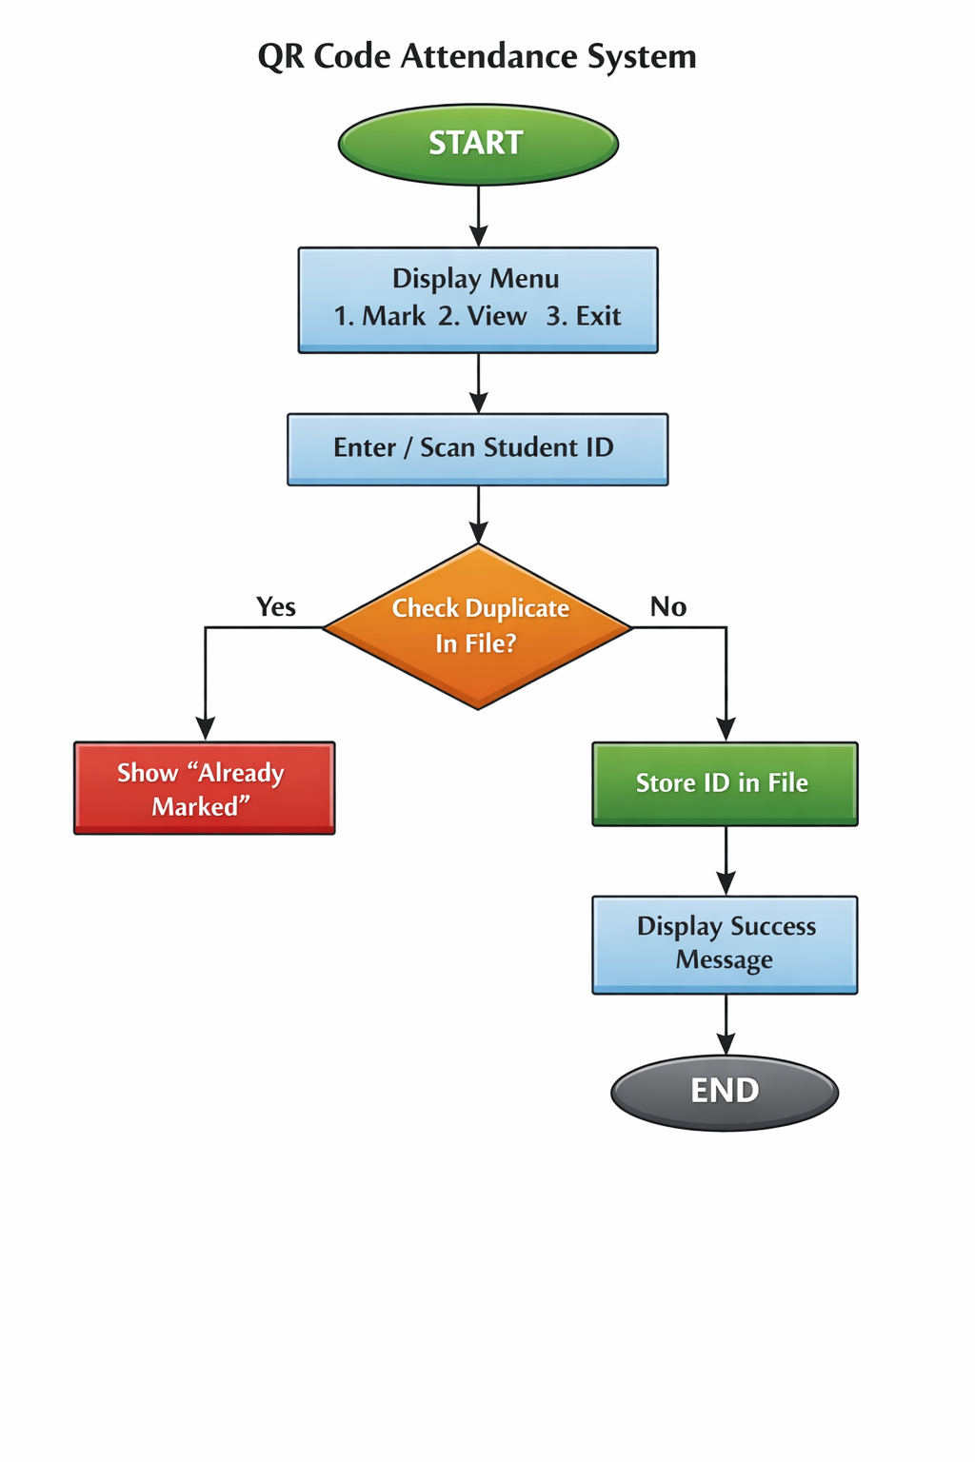

9. Program Code
#include <stdio.h>
#include <string.h>
#define FILE_NAME "attendance.txt"
int isAlreadyMarked(char id[]) {
FILE *file = fopen(FILE_NAME, "r");
char storedID[50];
if (file == NULL)
return 0;
while (fscanf(file, "%s", storedID) != EOF) {
if (strcmp(id, storedID) == 0) {
fclose(file);
return 1;
}
}
fclose(file);
return 0;
}
void markAttendance() {
FILE *file = fopen(FILE_NAME, "a");
char id[50];
printf("Scan QR Code (Enter Student ID): ");
scanf("%s", id);
if (isAlreadyMarked(id)) {
printf("Attendance already marked!\n");
} else {
fprintf(file, "%s\n", id);
printf("Attendance marked successfully!\n");
}
fclose(file);
}
void viewAttendance() {
FILE *file = fopen(FILE_NAME, "r");
char id[50];
if (file == NULL) {
printf("No attendance records found.\n");
return;
}
printf("\n--- Attendance List ---\n");
while (fscanf(file, "%s", id) != EOF) {
printf("%s\n", id);
}
fclose(file);
}
int main() {
int choice;
do {
printf("\n1. Mark Attendance\n");
printf("2. View Attendance\n");
printf("3. Exit\n");
printf("Enter your choice: ");
scanf("%d", &choice);
switch(choice) {
case 1:
markAttendance();
break;
case 2:
viewAttendance();
break;
case 3:
printf("Exiting Program...\n");
break;
default:
printf("Invalid choice!\n");
}
} while(choice != 3);
return 0;
}

10. Sample Input / Output

Sample 1:
Input:
1
S101
Output:
Attendance marked successfully!

Sample 2:
Input:
1
S101
Output:
Attendance already marked!

11. Result
The QR Code Based Attendance System was successfully implemented using C programming language. The program stores attendance data in a file and prevents duplicate entries.

12. Applications
- Classroom attendance system
- Office employee attendance
- Event participant tracking
- Digital record maintenance

13. Conclusion
This project demonstrates basic and intermediate C programming concepts such as file handling, functions, loops, and conditional statements. It also introduces real-world application development using structured programming.

14. Future Enhancements
- Add date and time stamping
- Store student names along with ID
- Add password protection for admin
- Generate attendance report automatically
- Integrate with real QR scanning hardware

15. References
- “The C Programming Language” by Brian W. Kernighan and Dennis M. Ritchie
- Online C programming tutorials
- Class notes and lab manuals

